North Loop Neighborhood Association
Community Garden Considerations
The North Loop Neighborhood Association (NLNA) is exploring options for a community garden to be implemented within the neighborhood. This exercise is intended to see what interest the neighborhood has in a community garden and determine the feasibility of such an endeavor.

Several community gardens exist within the Twin Cities (e.g. Dowling Community Garden, Satori Community Garden) and hundreds more are thriving in cities across the nation. The gardens vary in purpose from beautification to food production to education. However the benefits of these gardens are fairly well defined. An article published in the American Journal of Public Health states:

“Community gardens enhance nutrition and physical activity and promote the role of public health in improving quality of life. Opportunities to organize around other issues and build social capital also emerge through community gardens.”

Additional benefits of a community garden include:
- Community gardens foster the development of community stewardship and identity
- Community gardens bring neighbors together from vary backgrounds for a shared purpose, which may become a focal point for organizing to address social issues
- Community gardens reduce crime by bringing more eyes on the streets
- Community gardens are a great teaching tool for youth and adults alike to learn about what it takes to grow food, to learn job and life skills like patience and attention to detail, and to learn about environmental sustainability
- Community gardens provide an inexpensive source of nutritionally-rich foods
- Community gardens are a stress relief for gardeners and help them feel part of something larger than themselves
- Community gardens add beauty to the community by creating green space for people to retreat to as an contrast to the typical urban environment
- Community gardens have been shown to increase property values in the immediate vicinity where they are located (studied in New York)

Location of a Community Garden
The location is vital to the success of a community garden. Considerations have to be made to account for each of the following factors to determine the best location:
- Access to water
- Access to sunlight
- Ease of access for gardeners
- Visibility to passers-by (pedestrians or drivers)
- Security of the site
- Longevity of the site to be used for a community garden

Initial conversations on the topic have considered three potential sites. Each has its own pros and cons which require additional research. Additional site will certainly be open for consideration throughout the exploration and design phases of this project.

Site Option #1: Proposed Park Space

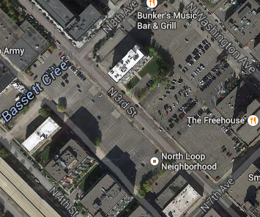

Approximate address = 747 North 3rd Street
Owner = Schafer Richardson
Pros:
- Site is the proposed location for a future park
- Easy access for pedestrians off 3rd Street (not-accessible to vehicles)
- Close proximity to residential buildings
- One point of contact for development approval
- A water spout is located off property but in close proximity on the 720 Lofts building
Cons:
- Minimal visibility being tucked behind a large parking lot and existing structures
- Trees and the 720 Lofts building blocks direct sunlight on the southwest most portion of the parking lot

Site Option #2: Distributed in Planters
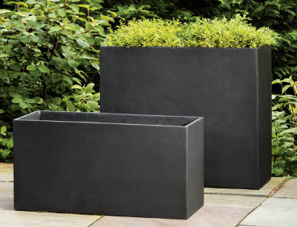
Approximate address = Varies; Ideal locations would be double width sidewalks
Owner = City ROW
Pros:
- Property is owned and well within guidelines to place planters within
- Can be dispersed to be in close proximity to residents wishing to garden
- Beautify the neighborhood
- Ample opportunities to place in sunlight
- High visibility with opportunity to recognize gardeners with signage
- Easily scalable with planters only placed as desired
Cons:
- Cost of purchasing planters
- Lack of cohesive identity for the garden
- Gardener would be responsible for sourcing their own water

Site Option #3: Fire Station
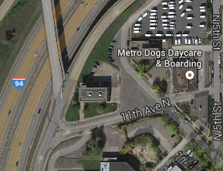

Approximate address = 1101 North 6th Street
Owner = Minneapolis Fire Department (Station #4)
Pros:
- Security being next to the fire station
- Potential longevity of the site to be used as a garden
Cons:
- Lack of residents in close proximity
- Very difficult access due to the distance and poor pedestrian experience
- Zero visibility
- Possible access to water off of the fire station but this is a significant distance away

Site Option #4: Star Tribune

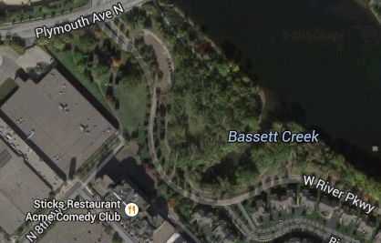

Approximate address = 800 North 1st Street
Owner = Star Tribune/Park Board
Pros:
- Proximity to the park space and residents
- Visibility to the community while not immediately on the high traffic trail
Cons:
- No water source on the northeast side of the Star Tribune building
- Steep graded hill along the property line, shaded by the building off the hill
Construction of a Garden
Community gardens come in all different shapes and sizes. The design that best fits a North Loop community garden will depend on funding, public interest in gardening, and restrictions of the site. Initial conversations have focused on two forms of gardening with the preferred method being straw bale gardening.

Form Option #1: Straw Bale Gardening
Description: Rather than constructing a container with soil placed inside, a straw bale serves as both the container and the soil for plants. The straw is held together by string which is top with a thin layer of top soil. After two to three weeks of exposure to rain and sun, the bale begins to decompose which means it is “conditioned” and ready to plant.

Pros:
- Typically a significant cost savings over constructing raised beds with purchased soil
- Easy installation on any surface type
- Clear designation of ownership plots
- Highly visible due to their raised nature
- Ideal planting conditions with no weeds or soil remediation needed
- Previous year’s bales can be broken down and spread as mulch

Cons:
- Bales decompose which means they have a ~2 year life span
- If the bale is not tightly secured, straw may fall out of the bale and spread easily
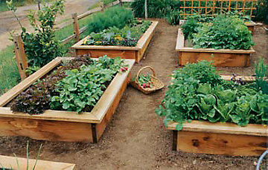
Form Option #2: Raised Bed Gardening
Description: Creating a container to hold fertile soil above the existing surface. Typically 6-8 inches deep, raised beds can vary greatly in size and shape. The standard community garden uses beds about 4’x8’ to give gardeners ample space for their use.

Pros:
- Typical form used in existing community gardens which means gardeners and the community is expecting this style of gardening
- Well-constructed beds can last for multiple years with minor maintenance needed
- Allows for clean, fertile soil to be added on top of the existing surface
- Facilitates more varieties of plants than a straw bale, particularly root vegetables and corn
Cons:
- Represent a significant cost to install depending on the material chosen
- If placed on existing asphalt, the asphalt heats up which damages plants if a significant layer of soil is not placed as a barrier
- Should not be used on sites with contaminated soil as plant roots may penetrate through the raised bed to the soil below

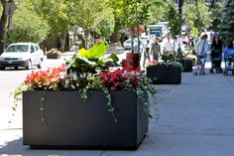
Form Option #3: Sidewalk Planter
Description: Providing the opportunity for North Loop residents to garden without the requirement of a large dedicated gardening space. Decorative planters large enough for residents to grow a small garden can be placed on wide sidewalks with ownership assigned to volunteer gardeners.
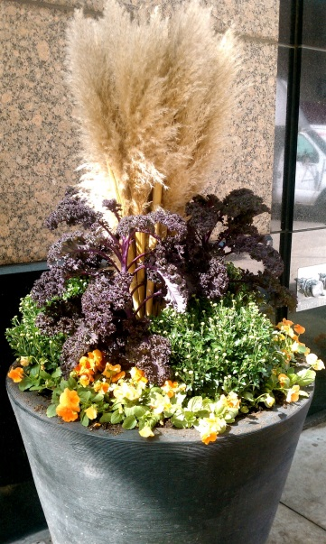
Pros:
- Planters are help the neighborhood create an identity
- Residents have a sense of ownership of the shared space
- Planters would last for years with little maintenance required
- Moveable to allow for relocation (if desired)
- Only have to buy the number of planters that residents register to maintain making the program something that can start small and expand if demand requires
Cons:
- Significant initial investment with each planter costing $300-$1500
- Poorly maintained gardens would be highly visible

Additional Considerations Needing Further Exploration
- Funding source(s)
- City ordinances governing community gardens
- Long term ownership of the garden
- Advertising of the garden
- Gardener membership requirements

Appendix
Below is a list of sites considered for a garden location but passed due to the cons described.

Eliminated Site Option: Highway Right-of-Way

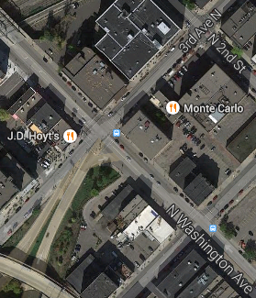

Approximate address = 225 North Washington Ave
Owner = Unclear Government Ownership
Pros:
- Visibility to both drivers (existing 394 and on Washington Ave) and pedestrians
- Easy access immediately off of Washington Ave
- Relatively close proximity to residential buildings
Cons:
- Lack of residents in close proximity
- Unclear authority of ownership
- Noise pollution from cars exiting the highway and a busy intersection
- Condition of the site currently (debris from the highway and slope of terrain)
- Access to water

