

**North Loop Neighborhood Association**

**Board Meeting Notes**

**March 30, 2016**

**7:00 PM – 8:30 PM**

**Heritage Landing, 415 1st Street North**

**Attendees**: Philip Ailiff, Tim Bildsoe, Katie Day, David Frank, DJ Heinle, Bryan Hollaway, Fritz Kroll, Diane Merrifield, Francesco Parisi, Scott Woller

**Absent:** JR Maddox

1. March Board Meeting called to order at 7:00 PM; those in attendance introduced themselves by stating names and building of residence or business of employment in the neighborhood.
2. **A motion is made (Tim), seconded (Diane), and approved by the Board to approve the March Board Meeting Agenda.**
3. **A motion is made (Philip), seconded (Tim), and approved by the Board to approve the February 24, 2016 Board Meeting Minutes.**
4. COUNCIL MEMBER PRESENTATION

* Councilmember Jacob Frey was unable to make it to this meeting.

1. FINANCE REPORT –Tim Bildsoe

* This is Tim’s first meeting in the role of Treasurer.
* Prior to this meeting Tim sent out the complete financials and current balances of NLNA checking and saving accounts at Sunrise Bank.

Tim will work from formats used in the past provided by David, but can certainly provide other information if there is feedback. He also plans on sending an email on the day of each board meeting showing bank account balances.

* Tim is authorized on the accounts at Sunrise Bank and the corporate resolution has been taken care of.
* Tim plans on setting up a meeting with the bookkeeper with the intent of creating a formal budget. If the board agrees, Tim would like to meet with the bookkeeper in the next 30 days. David thinks this is a great idea and wanted to clarify that this should not raise any eyebrows.
* When was the last time there was an audit? Tim recommends that is there has not been one for a few years we should invest in having an audit done this year. David also thinks this a great idea. David suggested that Tim get a few quotes an audit.
* DJ shared that budgets have worked well in other organizations. Scott shared that having a budget would provide useful data about events and neighborhood investments.
* DJ asked if the check for YouthLink was written, Tim confirmed that the check was written and sent.

1. NEIGHBOR COMMENTS
2. Voting Precincts Update – Tim Schwarz, City of Minneapolis Elections Office

* Tim handed out a map (shown below) showing the updated voter precincts.
* The precincts were adjusted to create more balance long term.
* The change affects residents living in precincts 3-8 and 3-12. The change also means those effected by the change will have a new polling location.
* This change has an effective date of May 11. Tim explained that the map will be made available online in May and those affected will be notified by mail with a postcard.

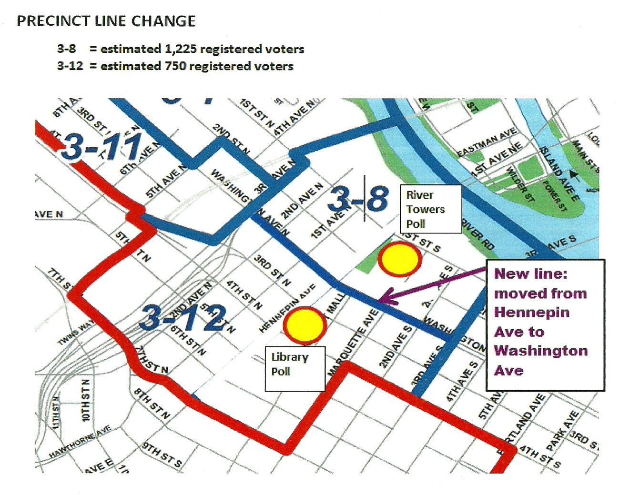

1. Additional Neighbor Comments

* 721 First Street North –Proposed Solhem Apartments: A neighborhood resident wanted to clarify that in the January 2016 NLNA meeting minutes the board agreed to support the proposed development that would be 4 levels with 2 levels of underground parking. The resident feels this is in conflict with the taller building that is now being proposed.
  + David stated that the board will look into this, but is not yet ready to say right now.
  + DJ also said that the developer Curt Gunsbury of Solhem can visit with the NLNA again if such a meeting is desired.
  + A few other neighborhood residents were concerned about the potential for flooding, the water table/basset creek, and property settling as a result of the proposed development at 721 First Street.
* Crosswalks and Pedestrian Safety: A neighborhood resident asked what the process of getting new stop signs and crosswalks installed looks like. Her primary intersection of concern is North First Street and 8th Avenue.
  + David said that the top priorities for NLNA will be discussed and picked at the board retreat and that crosswalks and pedestrian safety are always high on the list.
  + David suggested that she along with her concerned neighbors all write the exact same email to their council member expressing concern about this particular intersection.

1. COMMITTEE REPORTS
2. Marketing and Promotions – Scott Woller

* This past month a brief email newsletter was sent that primarily focused on website content. The goal this year is to send 6 e-newsletters. There were a lot of referrals from the newsletter to the website.
* 5th Annual North Loop Candy Grab on Saturday, March 26: The event was a success with about 150 kids and 220 adults in attendance. It was a very neighborhood targeted event.
* 7th Annual North Loop Earth Day Clean Up on Saturday, April 23: Scott distributed an informational flyer. The goal is to have 200 people either through work, condo, organizations, or individuals commit to cleaning up the North Loop for 1 hour. There is a Facebook event page for this event so please direct those that are interested to the Facebook event page for details.

1. North Loop Businesses – Scott Woller

* No update this month.

1. Website – Diane Merrifield

* Diane sent report to the Board prior to this meeting; report shows that volume is down overall, but there was a large spike in March following the newsletter sent via email. The volume spike went from 2,500 to 3,400 visits.

1. Planning + Zoning – DJ Heinle

* Tree Lighting: As discussed in a previous meeting, the board talked about trying to get some seasonal lighting in the trees. DJ contacted the City and they indicated that a special district needs to be created. DJ will follow up further to see what it would take to create this special district. DJ will give a report about this at another meeting.
  + David is also working with Hennepin County to wrap the railroad bridge with lights for this coming holiday season.

1. Livability – Greening & Lighting Update – Fritz Kroll

* Fritz will have an update with the tress that are being replaced. Please also let Fritz know if there are trees that are dead and dying.
* David asked about trees that are growing lots of little shoots – Fritz said he would find out who the contact is to have this maintenance done.
* Francesco asked who pays for these trees to install-David confirmed that upfront money was raised by NLNA and further on in the process Fritz has worked with property owners and private owners to help fund half.
* David noted that there is CAD document from many years ago that is a map of where it is possible to locate trees.
* Scott mentioned that a couple of the NL Banners are ripped and looking deteriorated. Either they should be put on the budget for new banners across the board or taken down. David noted that the banners could be a retreat topic.

1. Livability – Clean City application – Tim Bildsoe

* Tim looked into adopting a street to clean up in the North Loop. He has looked into the Clean Streets Minneapolis Program and the requirements are as follows:
  + Minimum of 6 blocks – Tim suggests 6 blocks on Washington Avenue.
  + Must be adopted for two years.
  + Area gets cleaned 4 times per year.
  + The city will put up a sign recognizing the group that adopted the area.
* Tim offered that he is willing to lead this charge to complete the application. Tim has to suggest 4 times of the year and has to indicate the 6-block space. Board members are asked to send date and location suggestions to Tim.
* **A motion is made (Tim), seconded (Fritz), and approved by the Board to authorize Tim to complete the application to adopt a street in the North Loop, notify of any fees, pick four dates, and pick a location.**

1. NL park update – Katie Day

* Greco has offered up the idea to host a block party this summer in support of the proposed North Loop park. They would want all of the proceeds to go to the park. The event could raise a small amount of funds and bring awareness to the idea of the park.
* Katie brought the block party idea to the park committee and what they are struggling with is the question of “is too soon?” Katie wants feedback from NLNA to report back to the park committee.
* The park will not approve the matter plan till at least June. Kit has given a 2-5 year timeline for the completion of the park because the park will be developed along with any potential development on the site.
* Funding for the park is also unclear at this point.
* The park committee thought it could be the proceeds collected could be for “greening the neighborhood” and not specifically for a park.
  + David thinks it is too soon to raise funds specifically for the park, but does agree that we are all about greening.
  + Scott thinks it is too soon as well.
* David asks that this block party is authorized/approved by the neighborhood since these types of events can cause some level of disturbance.

1. Safety and Livability – Phil Ailiff

* The last Block Club was on the 18th of February. They talked about the crimes that are most prevalent in the North Loop and if there were any significant changes, which there were not. The date for the next Block Club has not been decided however Phil proposed Thursday April 21st, but the official date will go out soon.
* Phil was contacted by the head of security from Be the Match asking if there are things they should be concerned about that neighborhood residents have had issues with. Phil suggested eliminating the opportunity to steal from cars. Phil said that they will try to stay in touch and the lines of communication seem to be open with them.
* The next Pedestrian Advisory Committee (PAC) Meeting is planned for Wednesday, April 6 from 4-6 PM in Room 333 of City Hall.
* The next First Precinct Court Watch is scheduled for Friday, April 8 at 10AM in the Doty Conference Room at the Main Library on the second floor.
* Everyone is cautiously on edge after the announcement was made that the officers involved in the shooting of Jamar Clark will not be prosecuted locally. A Black Lives Matter rally was being held at 6pm on 03/30/16.
* Last week’s march to Bachelor Farmer was held with no incidents.
* Phil will arrange to have Mackenzie Turner Barber come talk about standardized crosswalks markings at a future meeting, next month or the month after.
* The Heart of Blue called Phil informing him of a check issues from awhile back. David confirmed that the check was received on 03/30/16.

1. Sustainability/Community Garden – Bryan Hollaway

* During last month’s meeting the board approved that NLNA make a $500 contribution to the Beautify Your Balcony project. Bryan gave an update sharing that Mother Earth Gardens in Northeast Minneapolis is willing to give a year round 10% discount for the Beautify Your Balcony initiative. The $500 dollars will be given to Mother Earth Gardens to help offset their discount.
* Scott will help Brian create a coupon to be given to North Loop residents to use get the discount at Mother Earth Gardens with the hopes of beautifying balconies in the North Loop.

1. OLD BUSINESS
2. NRP funding update – JR Maddox not at meeting.

* JR Maddox is not at the meeting so an update will given at board retreat

1. 2020 Partners Update – David Frank

* Trying to make Target Field Station a community gathering space. They are planning on doing more community activities in that space.
* Diane asked for the contact person for Target Field Station Community Events – David will give contact information after the meeting regarding Chelsey Falzone.
* Target Center Improvements – Improvements will begin soon.
* Peter McLaughlin from Hennepin County asked and got support from 2020 partners to support transportation funds at the legislature.
* Metro Transit was present to talk about their police office building and an additional bus terminal.

1. DNG Update – DJ Heinle

* Meeting on 3/31 – Main topic of that meeting is preparations for the Super Bowl, DJ will give an update next month.

1. Minneapolis Downtown Families – David Frank

* NLNA received a thank you note for the contribution to the Fancy Pants Dance. The event raised over $400 dollars for People Serving People.

1. NEW BUSINESS

* By-laws Review: DJ sent the proposed updated draft of the by-laws prior to this meeting.

**A motion is made (DJ), seconded (Bryan), and approved by the Board to post the updated draft of the by-laws for public notice.**

The draft will be posted on the website for 15 days (this is the required public notice written into the by-laws); the Board will be asked to formally adopt the draft at the following Board meeting.

Diane noted that the current Google Map shown in the by-laws is incorrect. DJ will use the official City of Minneapolis map for the image in the by-laws.

* North Loop Bike Tour:
* Scott will suggest a few dates in June or July to do a bike tour of the North Loop guided by the NLNA Board Members.
* David clarified that a bike tour like this has not been done for some time (10 years or so) and shared that it is a good way to get to know the neighborhood.
* Board Retreat Date Selection:
* The board retreat was set for **Thursday April 21, 2016** **at 5pm.** David will confirm the location.

Meeting adjourned at 8:00 PM.

