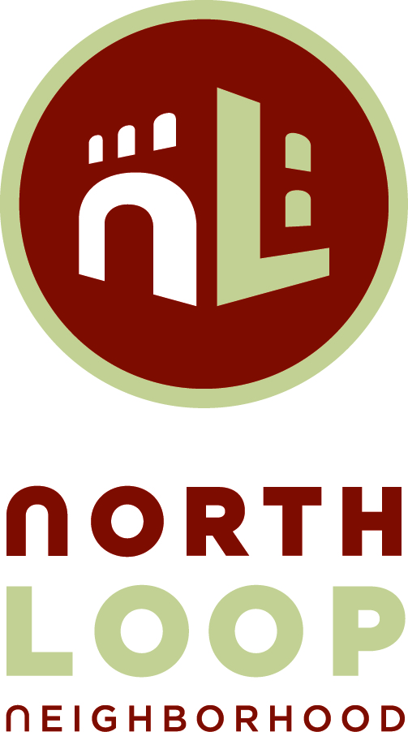
Agenda
North Loop Neighborhood Planning & Zoning Meeting
Heritage Landing Community Room, 415 North 1st Street
July 20, 2016
6:00 p.m. – 7:00 p.m.
TOPIC | FACILITATOR | ACTION NEEDED
- Welcome and Introductions | DJ Heinle
- Minutes | DJ Heinle | Accept
- Glenwood Ave Project | Kristy Morter, Hennepin County | Presentation
- C Line Alignment, and Route 9 Study | Terrence Anderson, Metro Transit | Presentation
- Red Rabbit Restaurant, 201 N Washington | Adam Meyer, Studio M Architects | For Approval
- Committee Business:  - Neighbor Comments  - Sub-Committee updates  - Art for Neighborhood Electrical Boxes  - Next Meeting August 24, 2016 | All Members | - Discussion
Attendance
2016 P&Z Committee: | DJ Heinle, Co-Chair |  |  | Karen Rosar
 | Dave Decker, Co-Chair |  |  | Jo Vos
 | Alice Eichholz |  |  | Kelly Nelson
 | Francesco Parisi |  |  | Neil Reardon
 | Darwin Lookingbill  Sydney Anderson |  |  | Mark Hill

