North Loop Neighborhood Association – Board Candidates 2024

Charlie Carlson – Resident/Renter
120 Hennepin Avenue, #313, Mpls MN 55401
Phone: 612.220.2831
Charliecarlson95@gmail.com

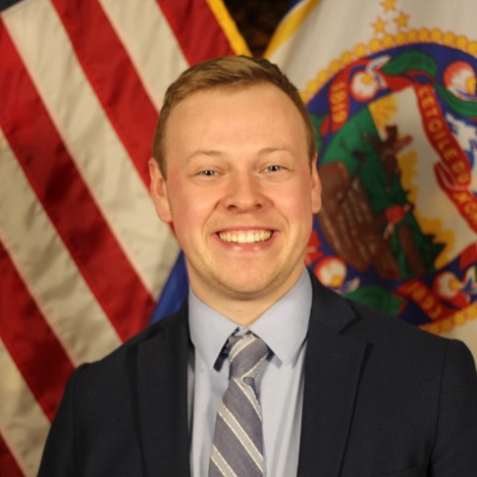

I have lived in Minneapolis my whole life but am a relatively new resident to the North Loop neighborhood. Before moving here, I spent almost all of my free time in the North Loop so in March 2023 my partner and I moved here! The North Loop is the most vibrant area of the city right now. There are constantly new things opening and exciting opportunities coming up.

I would love to be a part of the North Loop Neighborhood Association Board to continue to grow and create new opportunities in the neighborhood,

Professionally, I work for Meet Minneapolis, the convention and visitors’ association. I work in the Public Affairs department to ensure the Meet Minneapolis has strong relationships with City officials and elected officials at all levels of government and ensure they understand the importance of the visitor economy to Minneapolis. With the vibrant restaurants, shops and things to do, the North Loop is the most important place n the city right now and is playing a crucial role in the city’s recovery from the COVID-19 pandemic.

I want to join the NLNA board to become more involved in my neighborhood and give back to the community I plan to call home for many years.

Areas of Interest: Safety+Livability, Civic Engagement

John Dinusson – Resident/Owner
618 Washington Avenue N, #603, Mpls MN 55401
Phone: 119.522.1763
Email: john@advancedrecover.com
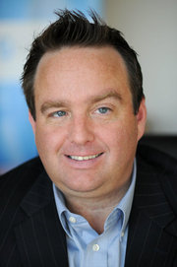
I have lived in the North Loop for approximately 5 years. I currently serve on the Boards of 2 nonprofits; Repowered and 180 Degrees which manages the Great River Landing and have a background of sitting on boards. I love the North Loop and I tend to be fairly community focused and like to participate in my community. I sat on the Harvester Board for several years and attempted to bring my building closer together by hosting several get togethers, etc. I am interested in finding out more about how I can help the North Loop be even better!

Areas of Interest: Finance, Governance, Planning+Zoning. Business Engagement, Community

Kristi Hamilton – Resident/Renter
730 1/2 N 1st Street, #538, Mpls., MN 55401
Phone: 612.518.3817
Email: kristiphamilton@gmail.com
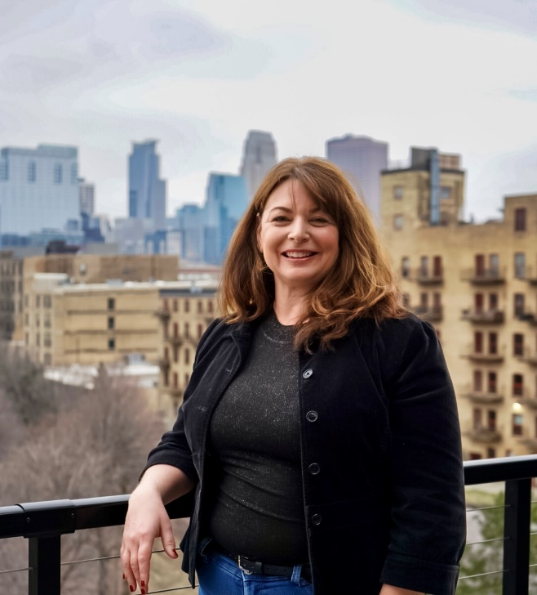

As a resident of the North Loop for over three years, I know firsthand the unique vibrancy of our city neighborhood set against the beautiful backdrop of the river, parks, and trails. In that time, I’ve been a dedicated volunteer with the many community engagement events, neighborhood safety block club, and business engagement. This helps me understand the association’s pivotal role in fostering a sense of community and connectiveness. My experiences as a marketing communication professional have equipped me with the skills needed to foster collaboration and engage a variety of stakeholders.

Through experience serving on non-profit and advisory boards, I am familiar with the dedication and hard work required by board members. I’m ready to deepen my commitment to the North Loop community and eager to take on a more active role in shaping its future by serving on the NLNA board.

If given the opportunity, I would like to focus time and energy to deepen our understanding of what safety and livability truly means to North Loop residents and businesses. I believe that by harnessing these insights, we can further strengthen existing initiatives and develop new ones to address the evolving needs of our community.

Areas of Interest: Safety and Livability, Civic Engagement

Jason Hines – Resident/Renter
625 N 2nd Street, #401, Mpls., MN 55401
Phone: 612.964.4237
jasonhines70@aol.com
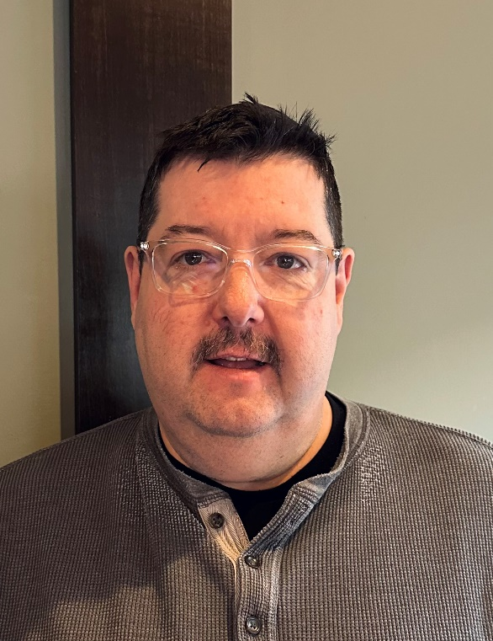
Hello, my name is Jason Hines. I grew up in the western suburbs and moved to the North Loop in March of 2020. No fun at all with all the shutdowns with Covid. I made it through, and the North Loop is a great place for fun.

Currently I am the Director of Operation for Lago Taco’s in Uptown and Excelsior. I am very interested in doing anything we can to keep our streets safe so all the residents and businesses can flourish.

I am a retired Firefighter/Paramedic. My time as a Paramedic was about 80% on the Northside
at night. This was quite the education. I still have a lot of friends in that industry that we can
gather information from to help stay connected with our Police and First Responders.
I have been on the Board of Directors of the I-94 Chamber of commerce for four years and went
to D. C. twice to lobby for I-94 Highway dollars. The project we lobbied for is now complete.
I think this is a good time to be involved. Thank you for considering me.

Areas of Interest: Safety+Livability, Business Engagement

Diane Merrifield – Resident/Owner
401 N 2nd Street, #613, Mpls MN 55401
Phone: 612.338.3711
damerrifield@mindbridgemarketing.com

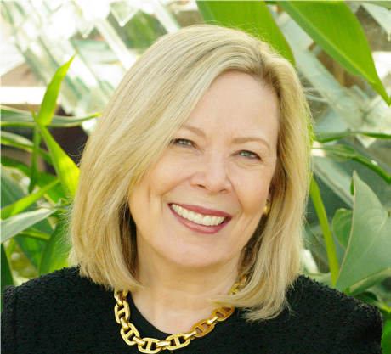

I moved to the North Loop in 2005, as the neighborhood was just emerging as the amazing presence it has become. It has been an incredible experience to have been a part of the past 18 years as the North Loop has come into its own as the shining light in our great city. When I moved here it was a pretty sleepy neighborhood with great plans for the future – with a population of around 1,500, growing to the population today of approximately 10,000.

I have been on the North Loop board since 2012, the past three years as president. Serving on the board and working with fellow board members and hundreds of volunteers is one of my most ever rewarding roles, and I hope to continue working on behalf of this great neighborhood for another term.

Areas of Interest: Strategic Direction, Communications

Andrew Morse – Resident/Owner
708 N 1st Street, #414, Mpls MN 55401
Phone: 415.920.3455
Email: andrew@morse.net

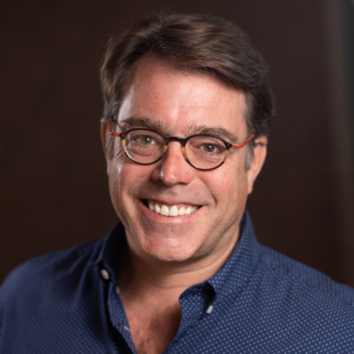

Five years ago, a small number of North Loop volunteers began undertaking small-scale habitat restoration efforts in James Rice Park, with a goal of restoring our treasured Mississippi River views and breezeways. Since that time, our efforts have become larger and more ambitious in scale, encompassing six acres of natural habitat in our river park. With the support of NLNA and conservation partners like Friends of the Mississippi River (FMR), our volunteer priorities have shifted from removing invasive species to developing new landscapes where invasive species once held sway.

My personal role in James Rice Park efforts has been leading Service Saturday volunteer events including seasonal invasive removal (Buckthorn, Ivy, Garlic Mustard, Burdock, Greater Celandine, etc.), shoreline cleanup, watering and mulching, and tree planting efforts. For example, in September 2021 and 2023, I led large-scale tree-planting efforts supported by dozens of volunteers and FMR conservation staff. Going into Winter 2024, we have 200 volunteer-planted trees in James Rice Park, each one protected and color-coded by species. I personally maintain the integrity of tree cover through the seasons and carefully track the survival rate of each to inform future efforts. I manage the James Rice Park Service Saturday calendar and work with NLNA to promote our seasonal events via social media. Using rudimentary marketing tactics like Lawn Signs with a QR Code and a free Google Business site, I have grown the North Loop Parks Volunteer Email list to 100+, a key source of labor. I also coordinate external Volunteer teems from Substance Church and U.S. Bank, which really boost our volunteer numbers. In 2023, we reported 1,000 Volunteer hours from 100 Volunteers – an astonishing amount of free labor. Last Year, NLNA named me one of the North Loop Super Volunteers – an exclusive group who rally other volunteers to action. Most satisfyingly, I am one of the handful of volunteers you will find getting their hands dirty on Saturday mornings, week-in, week-out, year-round and I love it when neighbors stop to ask questions or express gratitude.

Our efforts at James Rice Park are getting the attention of Minneapolis Parks & Recreation Bureau and many others. The North Loop is viewed as leading the Volunteer-led Habitat Improvement model in the Twin Cities, and neighborhoods like Sheridan across the river are following suit. When David Crary and I met five years ago, we agreed that Volunteerism is a force multiplier – and our work in James Rice Park is proof.

If elected to the North Loop Board of Directors, my goal is to act as Volunteer Coordinator for all North Loop efforts and building on our momentum. I would merge, segment, and grow our volunteer email lists, coordinate Volunteer events with the North Loop Board and seek ne Service Partnershops with local businesses and organizations.
Thank you for your consideration.

Areas of Interest: Parks+Placemaking, Communications

Louis Raymond – Resident/Renter
721 N 1st Street, #604, Mpls MN 55401
Phone: 612.888.1641
louisraymondact3@gmail.com

Hello! I’m a NoLo resident with many years of community Board, Committee & Officer experience in our previous home, Rhode Island (See the Charitable Service Section of my Wiki Page https://en.wikipedia.org/wiki/Louis_Raymond_(horticulturalist).. I & my husband Richard Ericson are new to MN & Minneapolis, and are way-impressed & energized about living here. More specifically, we are thrilled to be living in the NoLo, whose potential, buzz, achievements, & capabilities are impressive indeed.

Core priorities for me include community development, cultural breadth & depth, & inclusive economic opportunities. I have extensive experience with conceptualizing as well as realizing events at all levels & goals, from local pot-lucks to the Boston Flowershow, which (when I was involved) was attended by many hundreds of thousands each March. Professionally, I’m a landscape designer with decades of design/build experience, & am ramping up my practice here in MPLS – see http://www.LouisRaymond.Design hence my my interest & relevant expertise in public horticulture & exterior space design. Like you, I’m a roll-up-the sleeves-&-dig-in guy, who believes that deeper involvement is better than shallower.

It would be an honor to learn from – and contribute to- the NLNA’s board, which, clearly, has an impressive body of knowledge & solid track record. Thank you for your consideration! Louis

Areas of Interest: Community Engagement. Parks+Placemaking

Jeff Sondag – Resident/Renter
580 N 2nd Street, #400, Mpls MN 55401
Phone: 952.818.1406
jeffreysondag@gmail.com
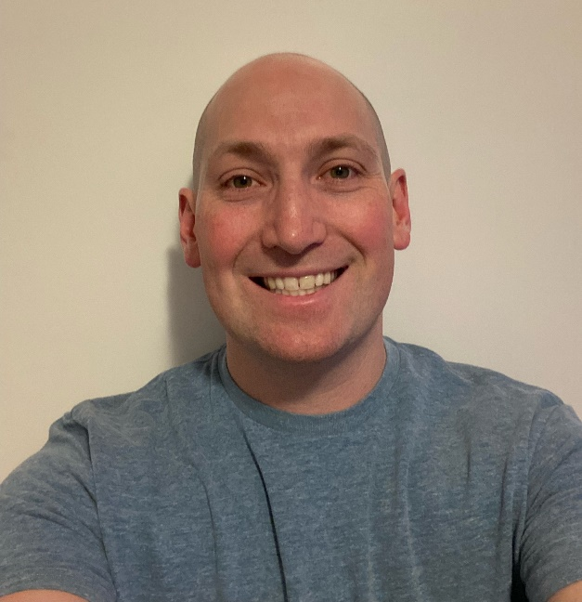

My name is Jeff Sondag and I’ve lived in the North Loop for the last 8 years with my wife. I’m currently serving on the Neighborhood Association board as well as the Planning & Zoning committee. I’m passionate about growing our neighborhood in a safe and sustainable way. I’m a big proponent of urbanism, density, mixed use development, strong communities, and safe streets. I aim to push the North Loop towards a more equitable built environment for pedestrians, cyclists, and public transport, with increased traffic calming measures and a better distribution of public space. I will continue to push for development that supports the local small businesses that create a diverse and culturally rich neighborhood.

Areas of Interest: Planning+Zoning, Safety+Livability

Sarah Sundahl – Business Owner
SPOKE612 Productions
701 N 3rd Street, #204, Mpls MN 55401
Phone: 952.201.5936
sarah@spoke612.com

My video production company, SPOKE612 Productions, moved into office space in the North Loop (Sherwin Williams Building) 2 1/2 years ago. When we were looking for a place for our business to call “home” we knew this is the area we wanted to grow in. We have built many relationships during our time here and are looking to continue to grow that.

This neighborhood has been instrumental in being a place clients and co-workers want to come to and has provided my company and would love nothing more than to give back to a community that has provided many resources for our productions. I am grateful for the opportunities the North Loop has provided my company and would love nothing more than to give back to a community that has provided so much. The North Loop will only continue to grow and I would love nothing more than to be a part of its future. I have never been on a Board of Directors before but I am the Director of my company and excel in a collaborative setting.

My professional background in production would be a perfect addition to assist with any communication-forward roles with the board. I have many resources to help get messaging out to the residents, business owners and more! Thank you for the opportunity to be a part of our “gem of the city.”

Areas of Interest: Community Engagement. Communications

Scott Woller – Business Owner
Corner Coffee / Corner Church
514 N 3rd Street, #102, Mpls MN 55401
Phone: 612.801.9233
Scott@cornerchurch.tv
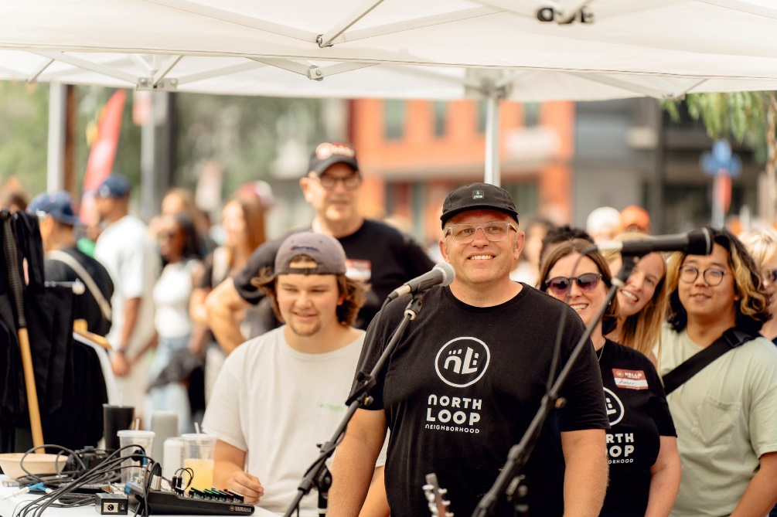
My name is Scott Woller. I have been serving on the North Loop Board for just over 6000 days (17 years). My wife, Amber, myself, and two very young daughters moved to the North Loop in 2005. In my desire to serve and invest in community, I made it a priority to find where the people that love and care for our neighborhood the most hang out. The North Loop Neighborhood Association quickly shined as being that place. It has been an honor to serve in many roles over the years, but most recently I have been working to see neighbors connected with neighbors as I have led community engagement. The hard work of putting together Food Truck Fairs, National Night Out Parties, Candy Grabs, Halloween Parties, and more has paid off a thousand fold in seeing beautiful moments of community, friendship, and connection at our events.

A little about me: I am the pastor of Corner Church here in the North Loop. We have Corner Coffee as well. We are currently in four Minneapolis communities, but the North Loop is our OG. My daughters are not so little any more. My wife and I have moved into a new downtown demographic as empty nesters. I have been honored to be a part of the neighborhood, but what I love is seeing you become a greater part of our community. Together, onward to a healthy community!

Areas of Interest: Community Engagement, Communications

